
Computer Network Project Report

Title: Hotel Network Management System

Submitted By:
Abdul Rafay (Roll No: 243705)
Course & Instructor:
Subject Instructor: Mr. Mohammad Azam
Subject: Computer Networks

Institution Details:
Air University, Multan Campus
Spring 2025

Table of Contents
Abstract 4
1. Introduction 4
Organizational Requirements 4
Network Topology: 5
2. Project Objectives 6
3A. Design Justification and Technology Selection 6
3. Network Design Methodology 7
Network Topology: 8
Topology Explanation and Justification 8
4. VLAN Design and IP Addressing Scheme 9
Traffic Management 9
Future Traffic Optimization 10
5. Devices Used in the Project 10
6. Physical Cabling and Port Mapping 11
7. Wireless Network Configuration (SSID & Security) 11
8. Standards and Protocols Used 11
9. Configuration: 12
9.1 Core Switch Configuration (CORE-SW-01) 12
9.2 Core Switch Running Configuration (CORE-SW-01) 13
9.3. Access Switch Configuration (VLAN Access Switches) 15
9.4 Core Switch to Core Router Connectivity (Layer-3 Link) 17
9.5 Core Router Configuration (CORE-RTR) 18
9.6 Firewall Configuration (ASA 5506) 18
9.7 ISP Router Configuration (ISP-RTR) 19
10. Server Configuration 20
11. Security Implementation 22
11.1 Traffic Flow Analysis (End-to-End Communication) 23
11.2 Troubleshooting and Failure Scenarios 24
11.3. Troubleshooting and Failure Scenarios 24
12. Security Threats and Mitigation Mapping 25
13. Testing and Validation 25
13.1 Testing Methods 25
13.2 Simulation Results 25
13.3 Troubleshooting Steps 27
14. Conclusion 27
Limitations 28
15. Future Enhancements 28

Abstract
Modern hotels rely heavily on secure and well-structured computer networks to support guest services, internal operations, and administrative management. This project presents the design and implementation of a comprehensive hotel network infrastructure using Cisco Packet Tracer. The proposed network follows a hierarchical architecture and employs Virtual Local Area Networks (VLANs) to logically segment different hotel departments such as parking, reception, guest areas, management offices, floors, IT control room, and security systems.
Centralized services including DHCP, DNS, and a web server are deployed to ensure efficient IP address management and internal service accessibility. Inter-VLAN communication is controlled through extended Access Control Lists (ACLs), while an ASA 5506 firewall is implemented to secure the network boundary and provide Network Address Translation (NAT) for internet access. Both wired and wireless connectivity are supported using access switches and wireless access points configured with VLAN-based SSIDs.
The project successfully simulates a real-world enterprise hotel network that emphasizes security, scalability, performance, and centralized management. Testing results confirm proper VLAN isolation, secure inter-VLAN access, and controlled internet connectivity, making the design suitable for practical deployment in hospitality environments.

1. Introduction
This project focuses on the design and implementation of a secure, scalable, and enterprise-grade hotel network using Cisco Packet Tracer. The network supports multiple departments, guest areas, management offices, and security systems while ensuring controlled access, traffic isolation, and internet connectivity. The design reflects a real-world hotel environment where wired and wireless users coexist under strict security and management policies.

Organizational Requirements
The hotel network is designed to fulfill the following organizational requirements:
Guest Requirements
- Secure wireless internet access in rooms, lobby, dining area, and parking
- Isolation between guest devices to prevent unauthorized access
- Reliable internet connectivity through firewall-protected access
Staff and Management Requirements
- Dedicated secure networks for reception, management, and IT staff
- Access to centralized servers such as DHCP, DNS, and Web server
- Controlled inter-department communication using access control policies
Security Requirements
- Separate VLAN for security systems (CCTV and monitoring)
- Firewall protection against external threats
- Restricted access to sensitive management and IT resources
Technical Requirements
- Automatic IP assignment using centralized DHCP
- Internal name resolution using DNS
- Scalability for future expansion

Network Topology:
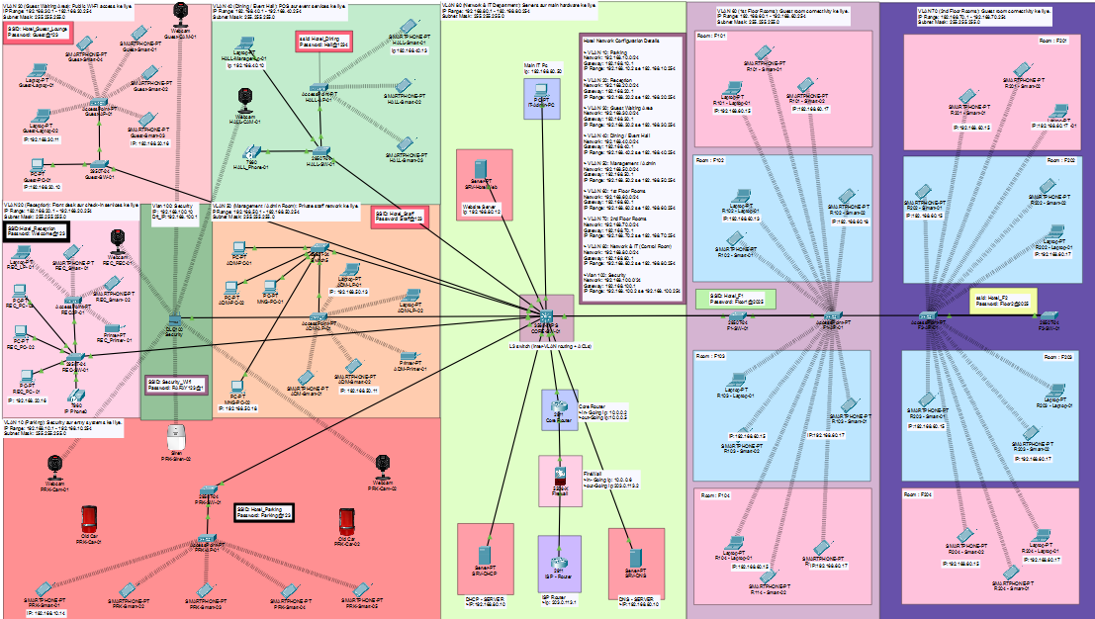

2. Project Objectives
The main objectives of this project are:
- To design a hierarchical hotel network
- To implement VLAN-based network segmentation
- To provide centralized DHCP, DNS, and Web services
- To enable secure wired and wireless connectivity
- To enforce inter-VLAN security using ACLs
- To protect the network using a firewall and NAT
- To allow controlled internet access for all users

3A. Design Justification and Technology Selection
Why VLANs Are Used:
VLANs are implemented to logically separate different hotel departments within the same physical network infrastructure. This segmentation reduces broadcast traffic, enhances network performance, and significantly improves security by isolating sensitive departments such as Management, IT, and Security from guest networks.
- Why a Hierarchical Network Model Is Used:
A hierarchical design consisting of core, distribution, and access layers provides better scalability, easier troubleshooting, and centralized control. This model allows the hotel network to expand in the future without redesigning the entire infrastructure.
- Why a Core Switch with Inter-VLAN Routing:
The core switch performs inter-VLAN routing using Switched Virtual Interfaces (SVIs). This approach offers faster routing compared to router-on-a-stick designs and enables centralized control of traffic between VLANs.

- Why Access Control Lists (ACLs):
Extended ACLs are used to control traffic flow between VLANs. They ensure that only authorized VLANs, such as Management and IT, can access critical resources, while guest and public VLANs remain restricted. This prevents unauthorized access and enhances internal security.
- Why Firewall (ASA 5506):
The ASA firewall is deployed at the network perimeter to protect internal resources from external threats. It enforces security policies, performs NAT, and controls inbound and outbound traffic, ensuring that internal networks are not directly exposed to the internet.
- Why Centralized Servers:
Centralized DHCP, DNS, and Web servers simplify network management, ensure consistent IP address allocation, and provide reliable internal services across all VLANs.

3. Network Design Methodology
A Hierarchical Network Model was adopted:
- Core Layer: CORE-SW-01 and Core Router
- Distribution Layer: VLAN-based access switches
- Access Layer: End devices and Access Points
A star topology is implemented where all VLAN switches connect to the core switch using trunk links.

Network Topology:
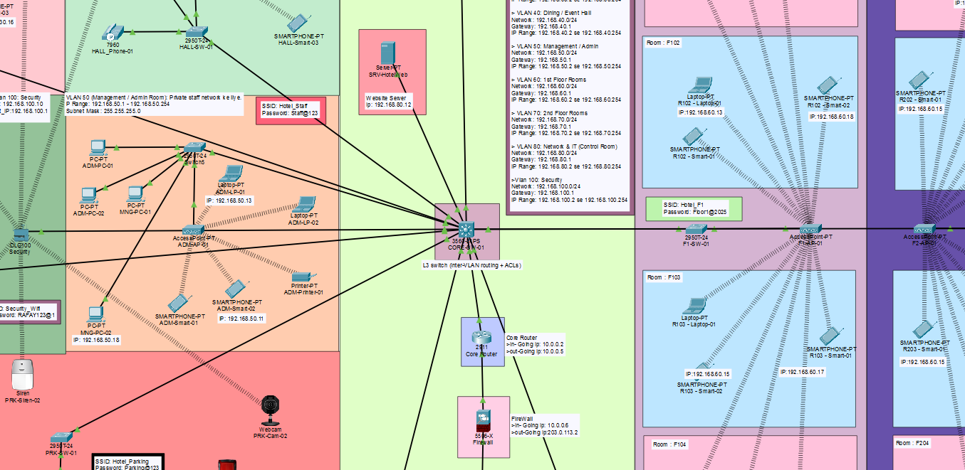

Topology Explanation and Justification
A hierarchical three-tier network architecture is used in this project, consisting of Core, Distribution, and Access layers.
Core Layer
- Handles inter-VLAN routing and high-speed traffic forwarding
- Central point for applying routing and security policies
- Improves performance and simplifies network management
Distribution Layer
- VLAN-based access switches aggregate departmental traffic
- Provides logical separation between hotel departments
- Enhances fault isolation and troubleshooting
Access Layer
- Connects end-user devices and wireless access points
- Implements port security and VLAN membership
- Provides reliable wired and wireless connectivity
This topology was selected because it improves scalability, enhances security, and allows easy future expansion without redesigning the entire network.

4. VLAN Design and IP Addressing Scheme
The hotel network is divided into multiple VLANs to isolate traffic and improve performance and security.
VLAN ID | VLAN Name | Network | Gateway
10 | Parking | 192.168.10.0/24 | 192.168.10.1
20 | Reception | 192.168.20.0/24 | 192.168.20.1
30 | Guest Waiting | 192.168.30.0/24 | 192.168.30.1
40 | Dining Hall | 192.168.40.0/24 | 192.168.40.1
50 | Management | 192.168.50.0/24 | 192.168.50.1
60 | 1st Floor Rooms | 192.168.60.0/24 | 192.168.60.1
70 | 2nd Floor Rooms | 192.168.70.0/24 | 192.168.70.1
80 | Network & IT | 192.168.80.0/24 | 192.168.80.1
100 | Security | 192.168.100.0/24 | 192.168.100.1

Traffic Management
Traffic management in the hotel network is primarily achieved through VLAN segmentation and hierarchical design.
- Each VLAN forms a separate broadcast domain, reducing unnecessary traffic
- Guest traffic is isolated from administrative traffic
- Centralized servers reduce cross-VLAN communication
- Layer-3 switching provides fast inter-VLAN routing

Future Traffic Optimization
- Quality of Service (QoS) can be implemented to prioritize voice and management traffic
- Load balancing and link aggregation can be added for improved performance

5. Devices Used in the Project
The following devices were used:
- Core Switch (CORE-SW-01) • DNS Server
- VLAN Access Switches • Web Server
- Core Router • PCs, Laptops, Smartphones
- ASA 5506 Firewall • IP Phones
- ISP Router • Wireless Access Points
- DHCP Server • CCTV Cameras & IoT Devices
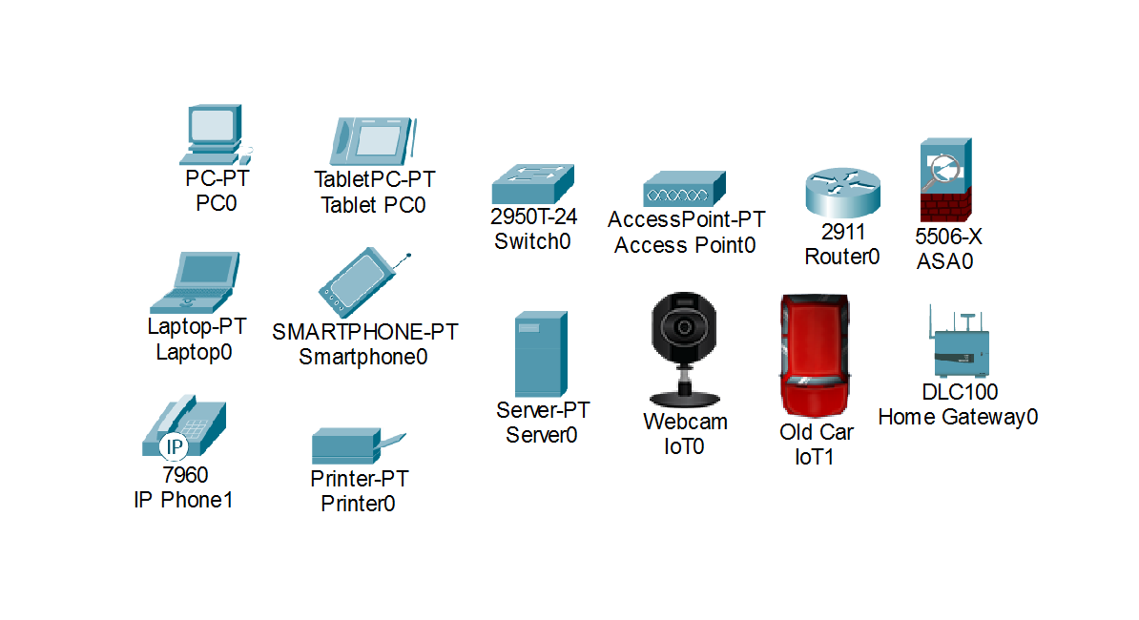
Devices:

6. Physical Cabling and Port Mapping
Straight-through cables are used throughout the network.
- End devices → Access switches (Access ports)
- Access switches → Core switch (Fa0/24 trunk links)
- Core switch → Core router (Layer-3 link)
- Core router → Firewall → ISP router

7. Wireless Network Configuration (SSID & Security)
Each VLAN has a dedicated SSID and password configured on its Access Point.
VLAN | SSID | Password
10 | Hotel_Parking | Parking@123
20 | Hotel_Reception | Welcome@123
30 | Hotel_Guest | Guest@123
40 | Hotel_Dining | Hall@1234
50 | Hotel_Staff | Staff@123
60 | Hotel_F1 | Floor1@2025
70 | Hotel_F2 | Floor2@2025

8. Standards and Protocols Used
The following networking standards and protocols were implemented in this project:
- IEEE 802.1Q (VLAN tagging)
- TCP/IP protocol suite
- DHCP (Dynamic Host Configuration Protocol)
- DNS (Domain Name System)
- NAT (Network Address Translation)
- ICMP (Internet Control Message Protocol)

9. Configuration:

9.1 Core Switch Configuration (CORE-SW-01)
The Core Switch acts as the central Layer-3 device for the enterprise network. It provides inter-VLAN routing, centralized VLAN control, and forwards user VLAN traffic toward the core router and firewall.
Implemented features
- VLAN creation and segmentation for departments
- SVI (Switched Virtual Interfaces) for each VLAN as the default gateway.
- ip routing enabled for inter-VLAN routing
- DHCP relay using ip helper-address toward the DHCP server (VLAN 80)
- 802.1Q trunk links to access layer switches
- Extended ACLs applied to control inter-VLAN communication and enforce isolation policies
Command: Show Ip Interface Brief.
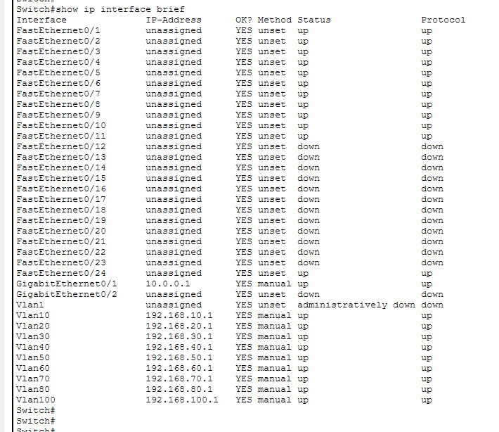

9.2 Core Switch Running Configuration (CORE-SW-01)
!
version 12.2(37)SE1
no service timestamps log datetime msec
no service timestamps debug datetime msec
no service password-encryption
hostname Switch
no profinet
ip routing
spanning-tree mode pvst

interface FastEthernet0/1
switchport access vlan 80
switchport mode access
interface FastEthernet0/2
description CONNECTION_TO_DHCP_SERVER
switchport access vlan 80
switchport mode access
interface FastEthernet0/3
description CONNECTION_TO_DNS_SERVER
switchport access vlan 80
switchport mode access
interface FastEthernet0/4
description CONNECTION_TO_WEB_SERVER
switchport access vlan 80
switchport mode access

interface FastEthernet0/5
switchport trunk encapsulation dot1q
switchport mode trunk
interface FastEthernet0/6
switchport trunk encapsulation dot1q
switchport mode trunk
interface FastEthernet0/7
switchport trunk encapsulation dot1q
switchport mode trunk
interface FastEthernet0/8
switchport trunk encapsulation dot1q
switchport mode trunk
interface FastEthernet0/9
switchport trunk encapsulation dot1q
switchport mode trunk
interface FastEthernet0/10
switchport trunk encapsulation dot1q
switchport mode trunk
interface FastEthernet0/11
switchport trunk encapsulation dot1q
switchport mode trunk

interface FastEthernet0/24
description LINK_TO_HOME_GATEWAY
switchport access vlan 100
switchport mode access

interface GigabitEthernet0/1
no switchport
ip address 10.0.0.1 255.255.255.252
ip access-group VLAN-CONTROL in
duplex auto
speed auto

interface GigabitEthernet0/2
switchport trunk encapsulation dot1q
switchport mode trunk

interface Vlan1
no ip address
shutdown

interface Vlan10
ip address 192.168.10.1 255.255.255.0
ip helper-address 192.168.80.10
interface Vlan20
ip address 192.168.20.1 255.255.255.0
ip helper-address 192.168.80.10
interface Vlan30
ip address 192.168.30.1 255.255.255.0
ip helper-address 192.168.80.10
interface Vlan40
ip address 192.168.40.1 255.255.255.0
ip helper-address 192.168.80.10
interface Vlan50
ip address 192.168.50.1 255.255.255.0
ip helper-address 192.168.80.10
interface Vlan60
ip address 192.168.60.1 255.255.255.0
ip helper-address 192.168.80.10
interface Vlan70
ip address 192.168.70.1 255.255.255.0
ip helper-address 192.168.80.10
interface Vlan80
ip address 192.168.80.1 255.255.255.0
interface Vlan100
ip address 192.168.100.1 255.255.255.0
ip helper-address 192.168.80.10

ip classless
ip route 0.0.0.0 0.0.0.0 10.0.0.2

ip access-list extended VLAN-CONTROL
permit ip 192.168.50.0 0.0.0.255 any
permit ip 192.168.80.0 0.0.0.255 any
permit ip 192.168.10.0 0.0.0.255 host 192.168.10.1
permit ip 192.168.20.0 0.0.0.255 host 192.168.20.1
permit ip 192.168.30.0 0.0.0.255 host 192.168.30.1
permit ip 192.168.40.0 0.0.0.255 host 192.168.40.1
permit ip 192.168.60.0 0.0.0.255 host 192.168.60.1
permit ip 192.168.70.0 0.0.0.255 host 192.168.70.1
permit ip 192.168.100.0 0.0.0.255 host 192.168.100.1
deny ip 192.168.0.0 0.0.255.255 192.168.0.0 0.0.255.255
permit ip any any

ip access-list extended VLAN-RESTRICT
permit udp any any eq bootpc
permit udp any any eq bootps
permit ip any 192.168.80.0 0.0.0.255
permit icmp any host 192.168.10.1
permit icmp any host 192.168.20.1
permit icmp any host 192.168.30.1
permit icmp any host 192.168.40.1
permit icmp any host 192.168.50.1
permit icmp any host 192.168.60.1
permit icmp any host 192.168.70.1
permit icmp any host 192.168.80.1
permit icmp any host 192.168.100.1
permit ip any 192.168.50.0 0.0.0.255
permit ip 192.168.50.0 0.0.0.255 any
permit ip 192.168.80.0 0.0.0.255 any
deny ip any 192.168.100.0 0.0.0.255
deny ip 192.168.0.0 0.0.255.255 192.168.0.0 0.0.255.255
permit ip any any
!
End

9.3. Access Switch Configuration (VLAN Access Switches)
Each access switch is responsible for connecting end devices (PCs, printers, APs, IP phones) into the correct VLAN while maintaining an uplink trunk to the core switch.
Implemented features
- Access ports bound to the correct VLAN (department-based)
- Trunk uplink (typically Fa0/24) toward CORE-SW-01 using 802.1Q
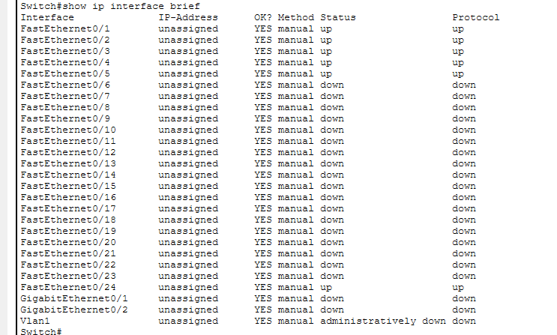
- Port security to reduce endpoint-level risks (MAC limit / sticky / violation modes)

Access Switch Configuration:
Switch#show running-config
Building configuration...

Current configuration : 1868 bytes
!
version 12.1
no service timestamps log datetime msec
no service timestamps debug datetime msec
no service password-encryption
!
hostname Switch
!
!
spanning-tree mode pvst
spanning-tree extend system-id
!
interface FastEthernet0/1
switchport access vlan 50
switchport mode access
!
interface FastEthernet0/2
switchport access vlan 50
switchport mode access
!
interface FastEthernet0/3
switchport access vlan 50
switchport mode access
!
interface FastEthernet0/4
switchport access vlan 50
switchport mode access
!
interface FastEthernet0/5
switchport access vlan 50
switchport mode access
!
interface FastEthernet0/6
switchport access vlan 50
switchport mode access
!
interface FastEthernet0/7
switchport access vlan 50
switchport mode access
!
interface FastEthernet0/8
switchport access vlan 50
switchport mode access
!
interface FastEthernet0/9
switchport access vlan 50
switchport mode access
!
interface FastEthernet0/10
switchport access vlan 50
switchport mode access
!
interface FastEthernet0/11
switchport access vlan 50
switchport mode access
!
interface FastEthernet0/12
switchport access vlan 50
switchport mode access
!
interface FastEthernet0/13
switchport access vlan 50
switchport mode access
!
interface FastEthernet0/14
switchport access vlan 50
switchport mode access
!
interface FastEthernet0/15
switchport access vlan 50
switchport mode access
!
interface FastEthernet0/16
!
interface FastEthernet0/17
!
interface FastEthernet0/18
!
interface FastEthernet0/19
!
interface FastEthernet0/20
!
interface FastEthernet0/21
!
interface FastEthernet0/22
!
interface FastEthernet0/23
!
interface FastEthernet0/24
switchport mode trunk
!
interface GigabitEthernet0/1
!
interface GigabitEthernet0/2
!
interface Vlan1
no ip address
shutdown
!
!
!
!
line con 0
!
line vty 0 4
login
line vty 5 15
login
!
!
!
!
end

9.4 Core Switch to Core Router Connectivity (Layer-3 Link)
A dedicated Layer-3 point-to-point network is used between the Core Switch and Core Router for clean routing and easy troubleshooting.
- Core Switch IP: 10.0.0.1/30 (Gi0/1)
- Core Router IP: 10.0.0.2/30 (Gi0/0)
- Default route on Core Switch: points to the core router (10.0.0.2) for outbound traffic

9.5 Core Router Configuration (CORE-RTR)
The Core Router forwards traffic between the internal VLAN environment and the firewall. It holds routing toward the inside networks and sends unknown traffic (internet-bound) toward the ASA.
Implemented features
- Static route for enterprise VLAN supernet toward the core switch
- Default route pointing toward ASA inside interface
Core Router Running Configuration (CORE-RTR)
!
version 15.1
no service timestamps log datetime msec
no service timestamps debug datetime msec
no service password-encryption
hostname Router
ip cef
no ipv6 cef

interface GigabitEthernet0/0
ip address 10.0.0.2 255.255.255.252
duplex auto
speed auto

interface GigabitEthernet0/1
ip address 10.0.0.5 255.255.255.252
duplex auto
speed auto

interface GigabitEthernet0/2
shutdown

ip classless
ip route 192.168.0.0 255.255.0.0 10.0.0.1
ip route 0.0.0.0 0.0.0.0 10.0.0.6
!
end

9.6 Firewall Configuration (ASA 5506)
The firewall enforces boundary security between the internal enterprise and the ISP (internet simulation). It performs NAT and runs inspection to protect traffic flows.
Implemented features
- Inside/Outside zones with security levels (inside = 100, outside = 0)
- NAT (PAT) for internal networks using outside interface
- Static routes (inside networks toward core router; default toward ISP)
- Basic inspection policy (DNS/FTP/ICMP/TFTP)
ASA Running Configuration (ASA 5506)
ASA Version 9.6(1)
hostname ciscoasa
names

interface GigabitEthernet1/1
nameif inside
security-level 100
ip address 10.0.0.6 255.255.255.252

interface GigabitEthernet1/2
nameif outside
security-level 0
ip address 203.0.113.2 255.255.255.252

object network INSIDE-NET
subnet 192.168.0.0 255.255.0.0
nat (inside,outside) dynamic interface

route inside 192.168.0.0 255.255.0.0 10.0.0.5 1
route outside 0.0.0.0 0.0.0.0 203.0.113.1 1

class-map inspection_default
match default-inspection-traffic
policy-map type inspect dns preset_dns_map
parameters
message-length maximum 512
policy-map global_policy
class inspection_default
inspect dns preset_dns_map
inspect ftp
inspect icmp
inspect tftp
service-policy global_policy global

telnet timeout 5
ssh timeout 5

9.7 ISP Router Configuration (ISP-RTR)
The ISP router provides an internet-facing endpoint for simulation. It has a public IP link toward the ASA and a return static route to the internal enterprise network.
Implemented features
- Public point-to-point IP addressing with ASA outside
- Static route back to internal networks via ASA outside interface
ISP Router Running Configuration (ISP-RTR)
!
version 15.1
no service timestamps log datetime msec
no service timestamps debug datetime msec
no service password-encryption
hostname Router
ip cef
no ipv6 cef

interface GigabitEthernet0/0
ip address 203.0.113.1 255.255.255.252
duplex auto
speed auto

interface GigabitEthernet0/1
shutdown
interface GigabitEthernet0/2
shutdown

ip classless
ip route 192.168.0.0 255.255.0.0 203.0.113.2
!
End

10. Server Configuration
DHCP Server
- Centralized DHCP for all VLANs
- Separate IP pools per VLAN
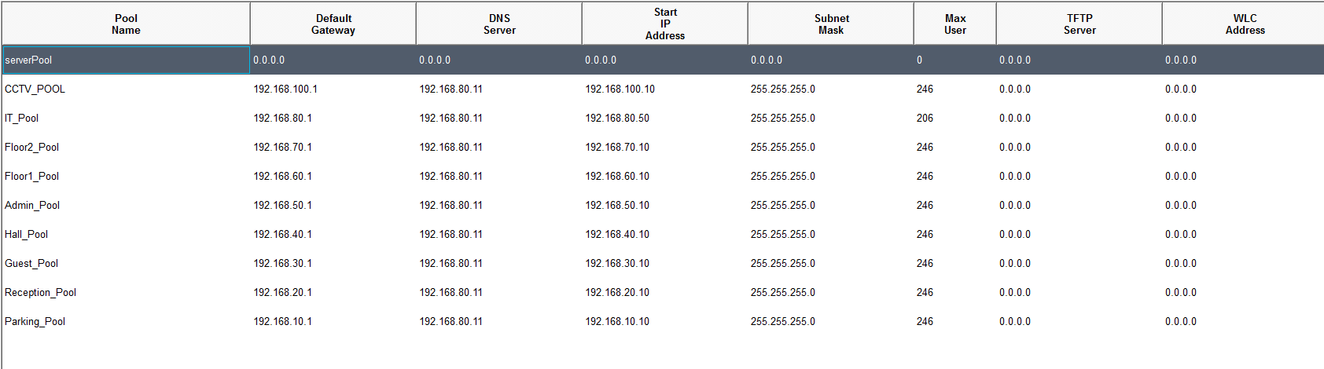
DNS Server
- Internal name resolution for users

Web Server
- Internal hotel website hosting

Site: security.safari.com
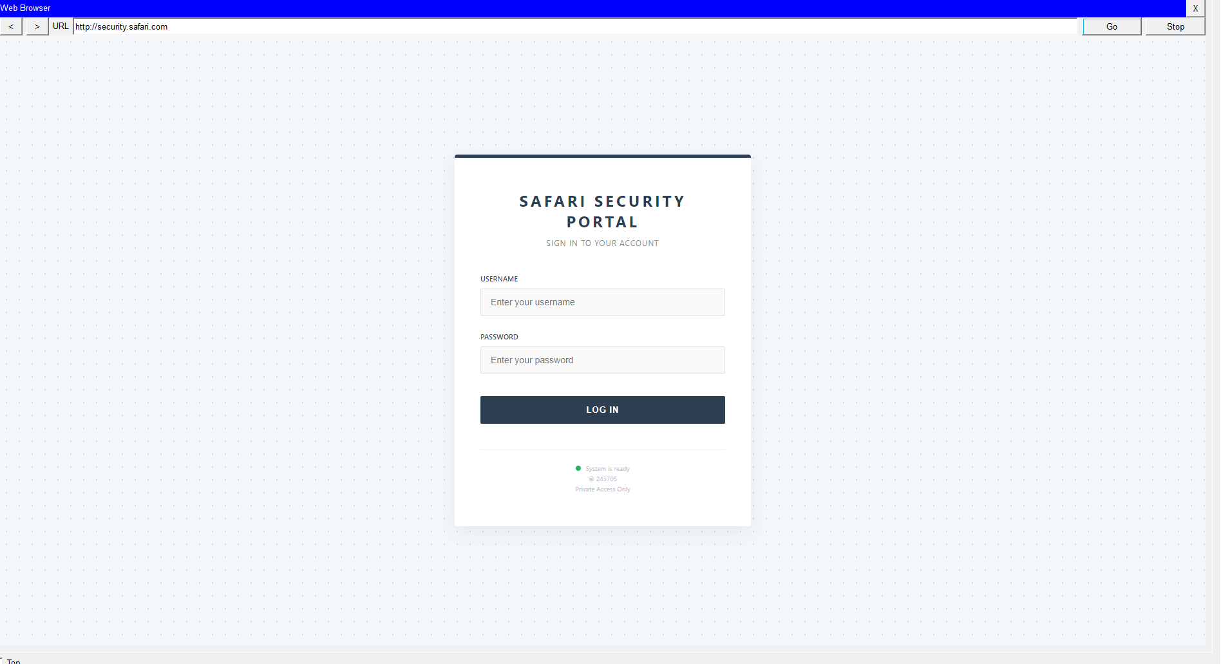

11. Security Implementation
Security is enforced using:
- VLAN isolation
- Extended ACLs on core switch
- Firewall rules and NAT
- Restricted access to Management & IT VLANs
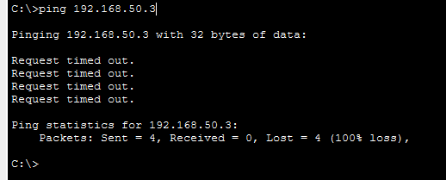
Guest to Admin:

Admin to Guest:
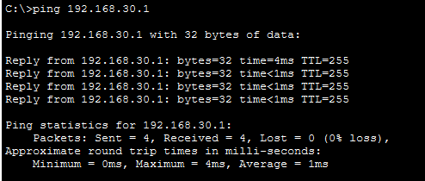
Internal Network to Isp:
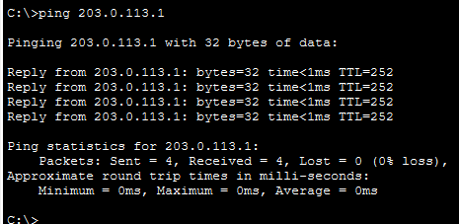
Isp to internel Network:
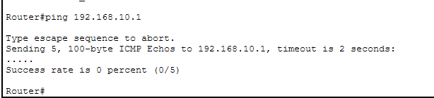
Admin to Isp:
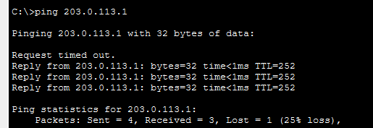
Firewall Log:

11.1 Traffic Flow Analysis (End-to-End Communication)
This section explains how data packets travel through the hotel network under different scenarios.
- Guest User Accessing the Internet
When a guest connects to the wireless network, the device associates with the Access Point of its respective VLAN. The traffic then passes through the access switch to the core switch. Inter-VLAN routing is performed at the core switch, after which the packet is forwarded to the core router. From the core router, traffic is sent to the ASA firewall where Network Address Translation (NAT) is applied before being forwarded to the ISP router and finally to the internet.
- Management User Accessing Internal Servers
A management PC sends a request that reaches the access switch and then the core switch. Based on ACL rules, the traffic is permitted and routed internally to the appropriate server VLAN without passing through the firewall, ensuring fast and secure internal communication.
- Wireless Client Obtaining IP Address
When a wireless client requests an IP address, the DHCP broadcast is forwarded by the core switch using the IP helper-address to the centralized DHCP server. The assigned IP address is then relayed back to the client through the same path.

11.2 Troubleshooting and Failure Scenarios
Security is enforced using:
- VLAN isolation
- Extended ACLs on core switch
- Firewall rules and NAT.
- Restricted access to Management & IT VLANs

11.3. Troubleshooting and Failure Scenarios
The following potential failure scenarios were considered along with troubleshooting approaches:
- Core Switch Failure: All VLAN communication would stop. Troubleshooting involves checking power, interface status, and configuration backups.
- DHCP Server Failure: Clients would fail to obtain IP addresses. Static IP testing and DHCP service verification would be performed.
- Firewall Blocking Traffic: Internet access issues would be diagnosed using ACL checks, NAT verification, and interface monitoring.
Common troubleshooting commands include ping, traceroute, show ip route, and show interface status.

12. Security Threats and Mitigation Mapping
Potential Threat | Implemented Mitigation
Unauthorized access | VLAN segmentation and ACLs
External cyber attacks | ASA Firewall
IP conflicts | Centralized DHCP
Broadcast storms | VLAN isolation
Data interception | Controlled routing and firewall policies

13. Testing and Validation

13.1 Testing Methods
The following testing methods were used to verify network functionality:
- DHCP IP address assignment for all VLANs
- Inter-VLAN connectivity testing using ping
- Internet access verification through firewall NAT
- DNS name resolution testing
- Wireless connectivity testing for different SSIDs

13.2 Simulation Results
The simulation results confirm that the network is functioning correctly.
- All VLANs successfully received IP addresses from the DHCP server
- Guest VLANs were restricted from accessing management and IT VLANs
- Management and IT VLANs were able to access internal servers
- Internet access was successful through the firewall using NAT
- Wireless devices connected securely and obtained correct IP settings

DHCP:
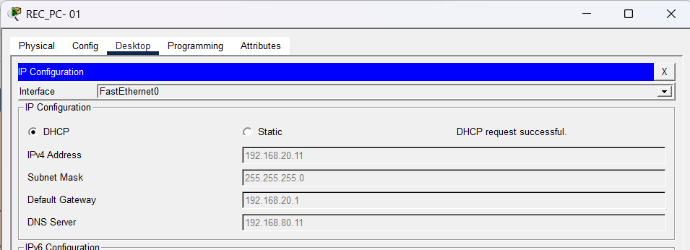
InterVlan:
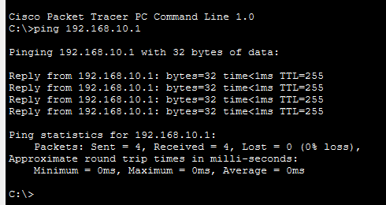
Internet:

Firewal:

13.3 Troubleshooting Steps
During implementation, the following issues were encountered and resolved:
- Inter-VLAN routing issue resolved by enabling ip routing on the core switch
- DHCP failure resolved by configuring ip helper-address
- Internet access issue resolved by adding a default route
- Firewall NAT issue resolved by correcting NAT configuration
These troubleshooting steps ensured stable and secure network operation.

14. Conclusion
This project successfully demonstrates the design and implementation of a secure, scalable, and well-structured enterprise network. The network uses VLAN segmentation, Layer-3 switching, and controlled routing to efficiently manage internal traffic while minimizing unnecessary broadcasts.
Security is enforced through extended ACLs, restricted access to critical VLANs, and a Cisco ASA firewall with NAT and inspection policies, ensuring protection against unauthorized access while allowing legitimate communication. The successful connectivity tests, including controlled internet access and restricted inter-VLAN communication, confirm that the security and routing policies are functioning as intended.
Overall, the implemented network fulfills the objectives of confidentiality, integrity, and availability, making it suitable for real-world enterprise and logistics environments with scope for future expansion.

Limitations
- Network implemented in simulation environment only
- No redundancy for core switch and firewall
- Dynamic routing protocols not implemented
- Quality of Service (QoS) not configured

15. Future Enhancements
- Implementation of QoS for voice and critical management traffic
- Load balancing and redundancy for improved availability
- VPN for remote management
- Wireless LAN Controller (WLC)
- Network monitoring & logging
- Redundant links and failover mechanisms

